Where the jobs are: How we did this report
MaryJo Webster, USA TODAY11:28 a.m. EDT October 14, 2014
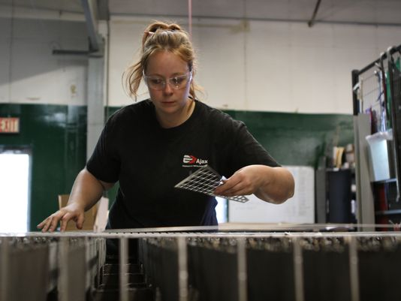
(Photo: usatoday)
To study what jobs are in demand and where, USA TODAY analyzed metro area-job projections created by Economic Modeling Specialists Intl. andCareerBuilder.
For each of 783 occupations, the data show the number of positions in that occupation in each of the top 125 most populous metro areas in 2013 and the projected number of jobs for 2017. It also indicates the percentage of workers who are nearing retirement (age 55 and older), the average number of annual openings, the median hourly wage and whether that is considered a living wage.
EMSI calculates these figures by blending data from the federal Bureau of Labor Statistics, U.S. Census Bureau, U.S. Bureau of Economic Analysis and other sources.
The living wage formula, created by the Massachusetts Institute of Technology, is specific to each metro area and is based on the amount needed to cover the basic needs of two adults and one child. Typically, that's about $14 per hour (the national median), but it varies by metro.
USA TODAY,with help from EMSI, identified a skill level for each occupation, based on the minimum education level needed for that occupation, according to the Bureau of Labor Statistics.
• Low-skill jobs are those requiring a high school diploma or less, and with a national median hourly wage of less than $13 per hour.
• Middle-skill jobs are those with a national median hourly wage of $13 or more, and education level of high school diploma or some postsecondary training but less than a bachelor's degree. (The BLS identifies many of these jobs as only needing a high school diploma, however other research shows some training, either on-the-job or with a non-degree certification, is usually required)
• High-skill jobs are those requiring a bachelor's degree or higher.
The data identified jobs that are considered Science, Technology, Engineering and Math (STEM) occupations by the Bureau of Labor Statistics.
To determine the risk that each occupation faces from automation or other forms of technology, USA TODAY obtained data from Carl Benedikt Frey and Michael A. Osborne, University of Oxford economics and computer science professors who in 2013 released a report, "The Future of Employment."
The Oxford data included a probability score for 702 occupations and identified those with a score of 74% or higher as being in "high risk" of being automated in the next 20 years. Those between 30% and 73% are in "medium risk" and the remainder are "low risk." USA TODAY matched those scores to the EMSI 2013 jobs data to estimate what percentage of jobs, by skill level and metro area, are in most danger.

