Search for Novels using the Online Catalog Catalog at Spokane Public Library (http://www.spokanelibrary.org)
- Click on Catalog at the top of the screen. A new search page opens
- Scroll down the search page to Additional Limits section. Find the subject field, and type one of the key words (search terms) from your “Developing Key Words” Worksheet.
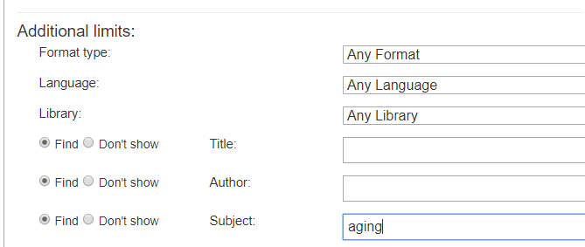
- Scroll further down the search page to the Limits section. Check the one of the appropriate boxes such as: fiction, or young adult fiction.
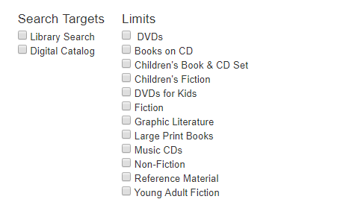

- Click on Advanced Search in the green bar.
- A list of titles opens.
- To further narrow your search, scroll through the Subjects in the Limit Search Results column on the left.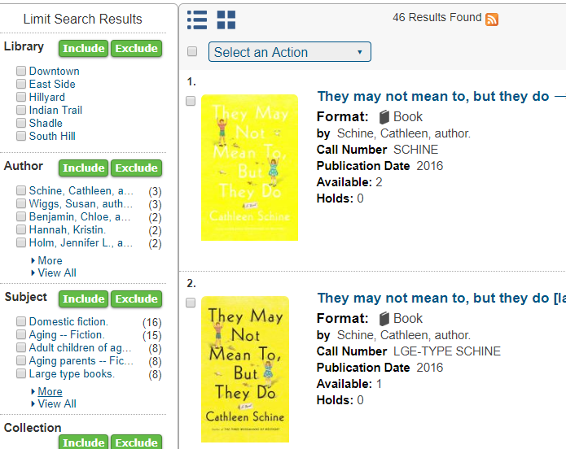
- Put a check in one of the subjects or click on More for more subjects. Click on Include.
- A list of titles appears. Read through the titles. When a title connects with your theme click on it to open it. The screen that opens after you click on a title is called the detailed record.
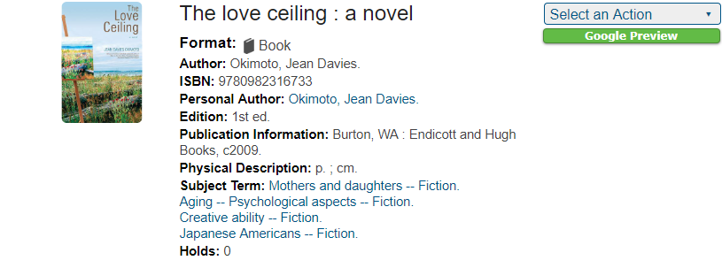
.

- To evaluate a title, read the detailed record and look for an abstract (summary). If there isn’t an abstract, find the summary tab.

- Does the summary connect to your theme? Did you find information about the author? YOU’VE GOT A WINNER! Print the screen if the title looks useful for your project.
IF YOU DIDN’T FIND A NOVEL THAT WORKS FOR THIS PROJECT
- Change your keywords. Use another keyword from the “Developing Key Words” worksheet and search again.
- OR
- Find one novel in this list that is appropriate for this project. When the title is opened all of its subjects are displayed. Click on any of the subjects and a new list of books appears. Search again through the new list
OR
- Look again in the Limit Search Results column on the left. Under Subject click more. Check boxes for subject headings that you want to include. Search again.

- If you didn’t find information on the author in the detailed record, search Amazon or do an internet search.

