Checklist for Editing Your Powerpoint

1. Check the spelling with Powerpoint’s Spell Check tool. Click on the Review tab. You’ll see the tool under File. Click on the tool.
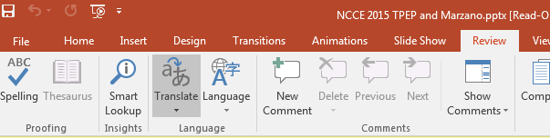
Your spelling errors will now appear with red wavy lines. If you aren’t sure about how to correct the errors ask another student or a teacher.
2. Do you have a Capital letter at the beginning of each sentence?
3. Have you capitalized proper nouns and names?
4. Have you placed an end mark (comma, period, question mark, exclamation point) at the end of each sentence?
5. Have you placed quotation marks around the quote from the text?
6. Did you put a parenthetical citation after the quote and a period after the parenthesis? It should look like this.
(Achebe 71).
7. Did you create a Works Sited slide? Copy the citations from the Annotated Works Cited list into this slide. Put the citations in alphabetical order.
8. Did you create a Photo Credits slide? Type a description of the photo. Place a colon after the description. Copy the internet address after that.

r.

