Search for Magazine Articles Using Explora Magazines at https://www.spokanelibrary.org.
- Type one of the keywords from your “Developing Keywords” worksheet in the large search window. Explora will provide suggestions for search terms as you type. Click on the orange Search button.
- A list of articles opens. It’s called the Search Results list. These are 2 articles in a search results list that resulted from a search using the term AGING.
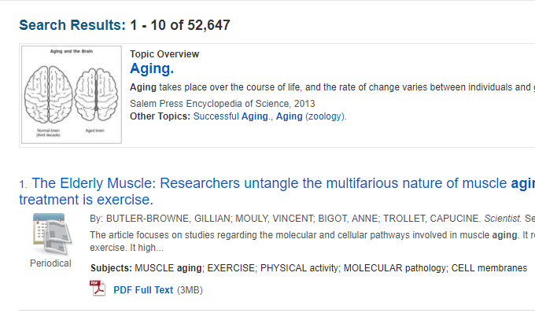

- To the left of the articles you will find the Refine Results column. Scroll down the column and put a check in Full Text.

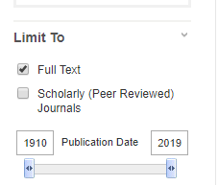

- If the title of an article looks as though it connects to your theme, open it by clicking on it. The full text of the article will open on the right.

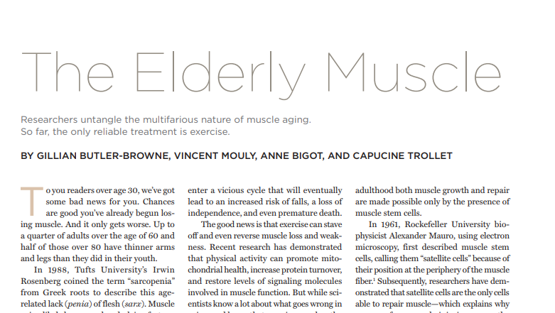

- On the left is a link to the Detailed Record and the PDF of the Full Text. Click on the link to the Detailed Record.

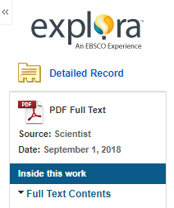

- The Detailed Record opens and shows you important details like the author, magazine the article came from , the subjects under which the article was catalogued, and the abstract (summary).

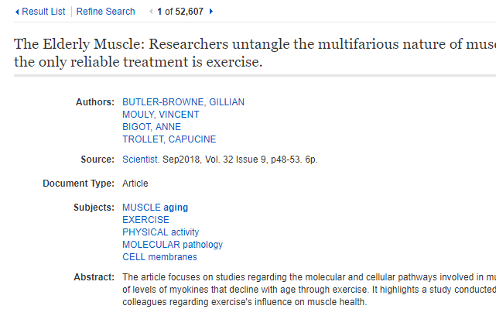

- Evaluate the article by reading the abstract. Does it connect with your theme?
- You can also evaluate the article by skimming/scanning the full text of the article. Did you find information about the author? YOU’VE GOT A WINNER! Print the article if it looks useful for your project.
IF YOU DIDN’T FIND AN ARTICLE THAT WORKS FOR THIS PROJECT
- Go back to the list of articles and continue to look at the titles of articles. Repeat this process of opening titles and clicking on the detailed records.
- Read through the subject headings that are shown in the detailed record. Click on any of the subjects and a new list of articles appears. Search through those articles.

